VISHWAKARMA UNIVERSITY
Academic Year: 2025-26 | Semester II
ADVANCED WEB TECHNOLOGY
NAME OF THE STUDENT : | Aaditya Dhanwate
DEPARTMENT : | ARTIFICIAL INTELLIGENCE & DATA SCIENCE
CLASS / DIV. : | TY / A
SRN : | 31230319
ROLL NO. : | 8

ASSIGNMENT NO.: 06
Create a Course Management System using MySQL Connectivity with Node.js
OBJECTIVE:
• Build a full-stack Course Management System using Node.js (Express) and MySQL
• Perform CRUD operations — Create, Read, Update, and Delete — on course records
• Set up a MySQL database (course_db) with a courses table and connect it via mysql2 package

Problem Statement: Create a Course Management System using Node.js and MySQL that allows users to Add, Edit, and Delete courses. The system must connect to a MySQL database (course_db) with a courses table storing course name, instructor name, duration, and fees, and display all available courses in a tabular format on the front end.
Output:
1. Course Management System – Add / Edit Course Form
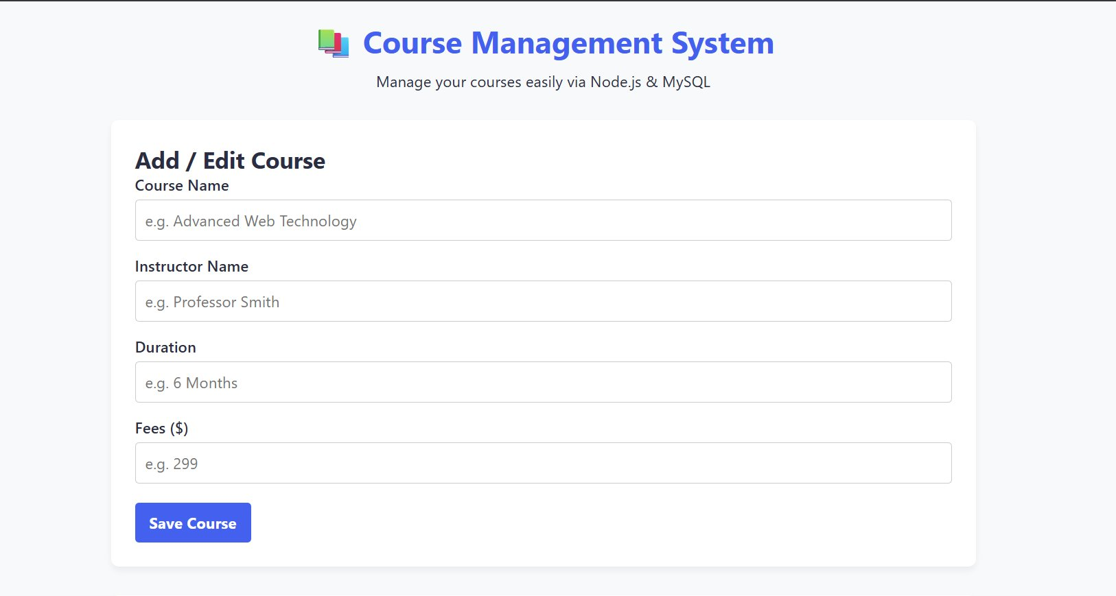
2. Available Courses List with Edit and Delete Actions
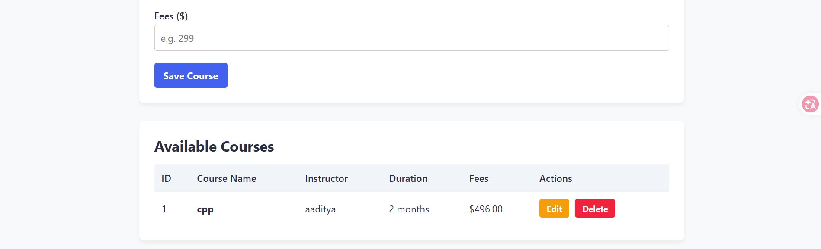
3. MySQL Database Setup – course_db and courses Table Creation
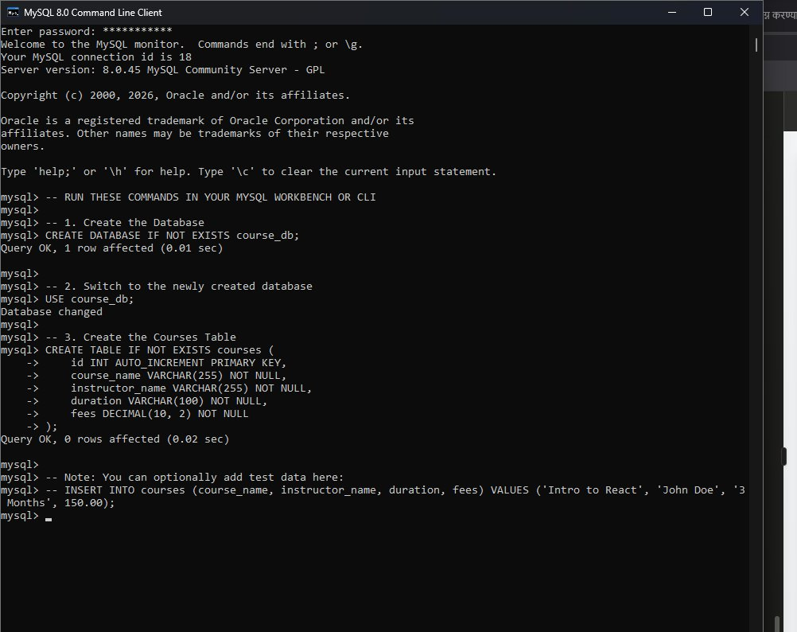

Conclusion:
In this assignment, a fully functional Course Management System was developed using Node.js with Express.js on the back end and MySQL as the database. The application supports complete CRUD operations — adding new courses, viewing all courses in a table, editing existing entries, and deleting records. The MySQL database (course_db) was set up via the command-line client and connected to the Node.js server using the mysql2 package, demonstrating practical full-stack web development with relational database integration.

